---  
title: "R Notebook for Time Series Forecasting of Stock Prices using ARIMA Model"

output: html_notebook  
---

```{r}

# Install and load necessary packages

install.packages("tidyverse")

install.packages("forecast")

library(tidyverse)

library(forecast)

# Step 1: Load the dataset

data <- read.csv("E:/US College/New folder/Predictive Analytics/Class Activity/Project/all_stocks_5yr.csv")

# Step 2: Preprocess the data

# Assuming you want to focus on a specific stock, let's say "AAPL"

stock_data <- data %>% filter(Name == "AAPL")

# Step 3: Explore the data

# Plot the time series of stock prices

ggplot(stock_data, aes(date, close)) +

geom_line() +

labs(x = "Date", y = "Stock Price", title = "AAPL Stock Price Time Series")

# Step 4.1: Time series modeling

# Assuming an ARIMA(1,0,1) model

model <- auto.arima(stock_data$close)

ts_data <- ts(stock_data$close)

# Step 4.2: Plot ACF and PACF

# ACF plot

acf(ts_data, main = "Autocorrelation Function (ACF) Plot")

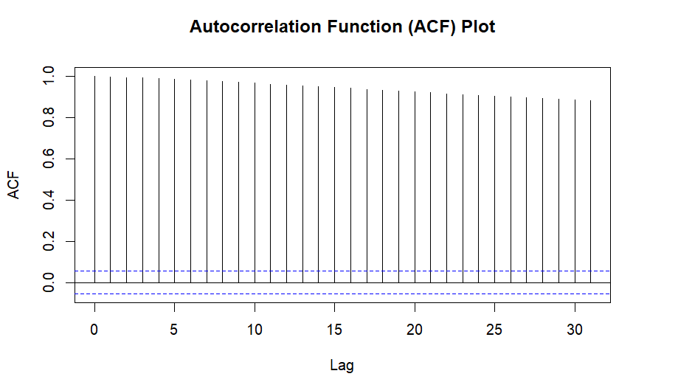

# PACF plot

pacf(ts_data, main = "Partial Autocorrelation Function (PACF) Plot")

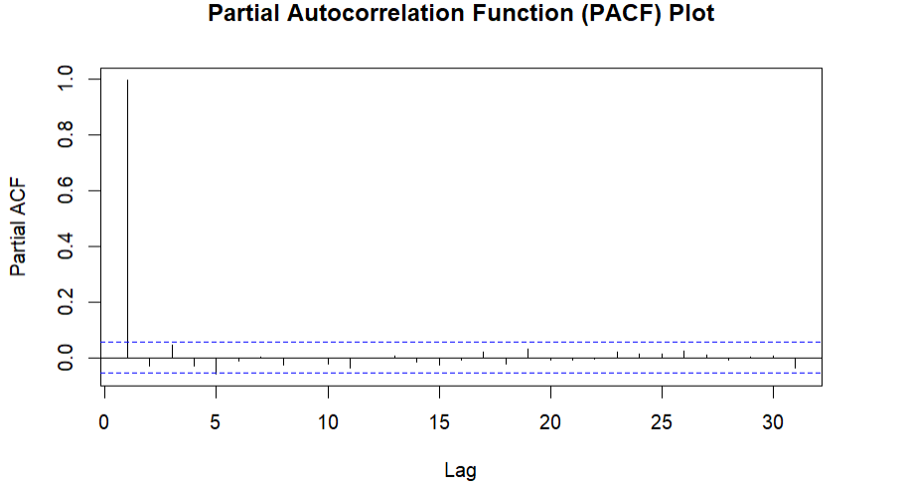

# Step 5: Model fitting and evaluation

# Split the dataset into training and testing sets

train <- head(stock_data, nrow(stock_data) - 12)

test <- tail(stock_data, 12)

# Fit the ARIMA model to the training data

fitted_model <- Arima(train$close, order = c(1, 0, 1))

# Evaluate the model using MAE and RMSE

forecast_values <- forecast(fitted_model, h = nrow(test))

accuracy(forecast_values, test$Close)

# Step 6: Forecasting

# Forecast future stock prices using the fitted model

future_forecast <- forecast(fitted_model, h = 12)

# Step 7: Plot the forecasted values

plot(future_forecast, main = "AAPL Stock Price Forecast")



